DDL Commands :

1.Table Creation (CREATE):
⦿ Departments
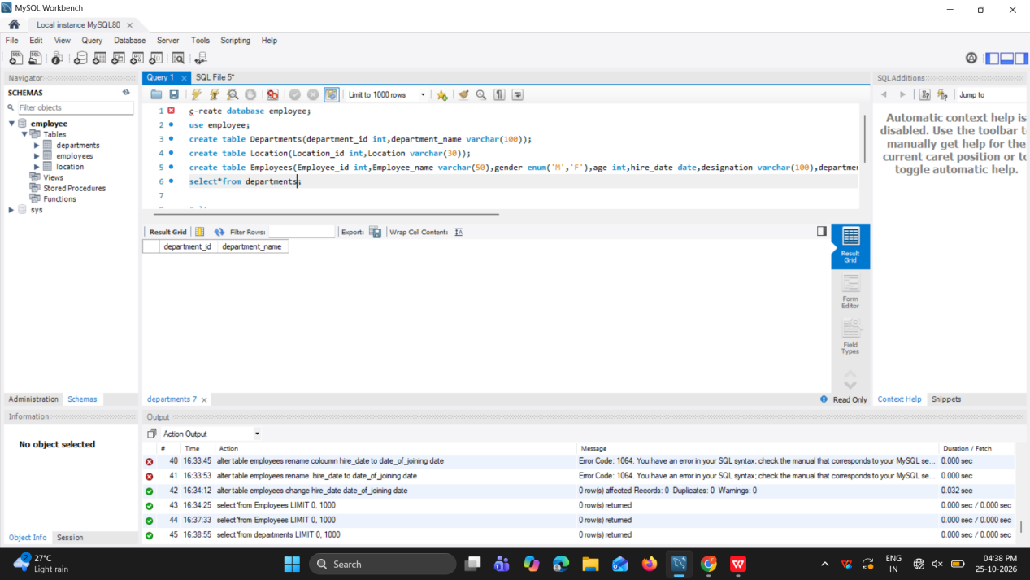
⦿ Location
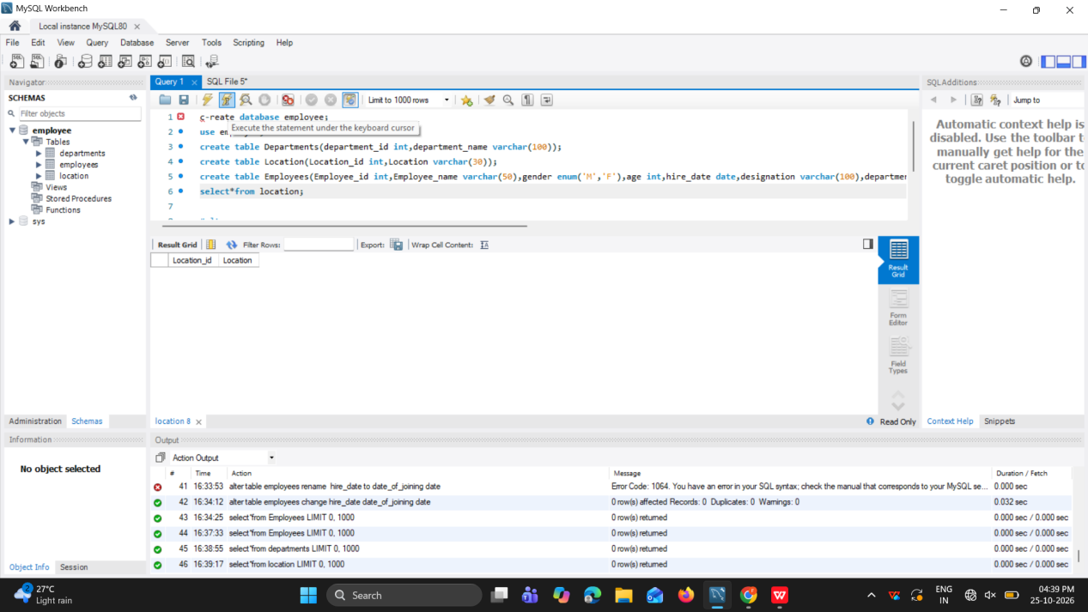

⦿ Employees

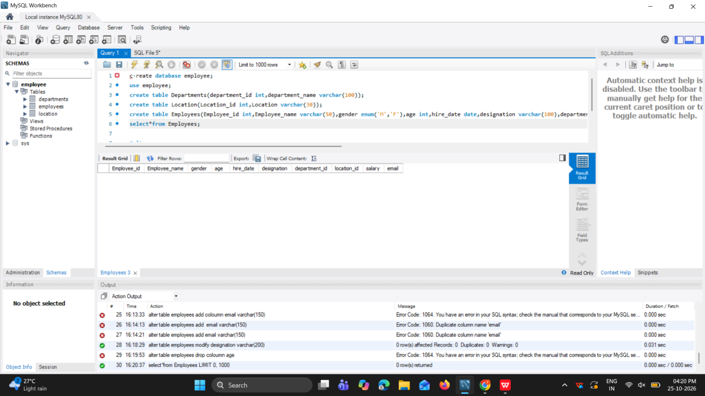

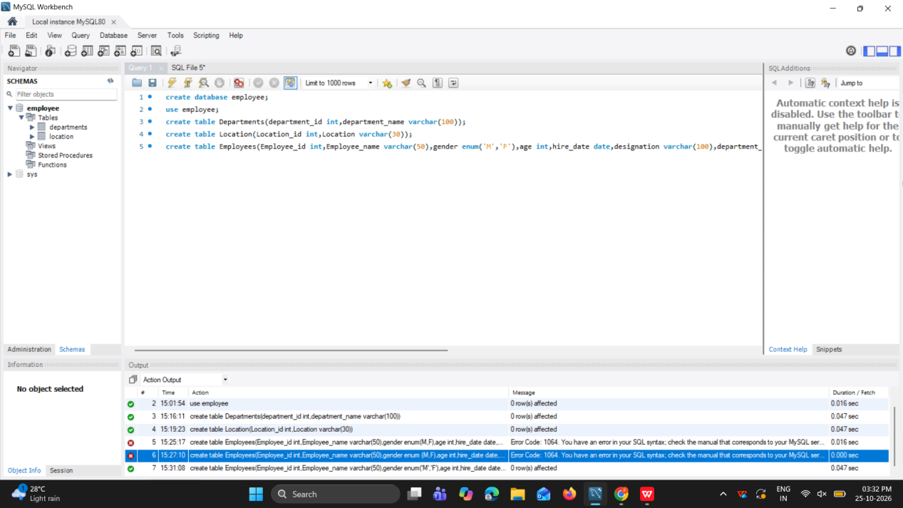

- Table Alteration (ALTER):
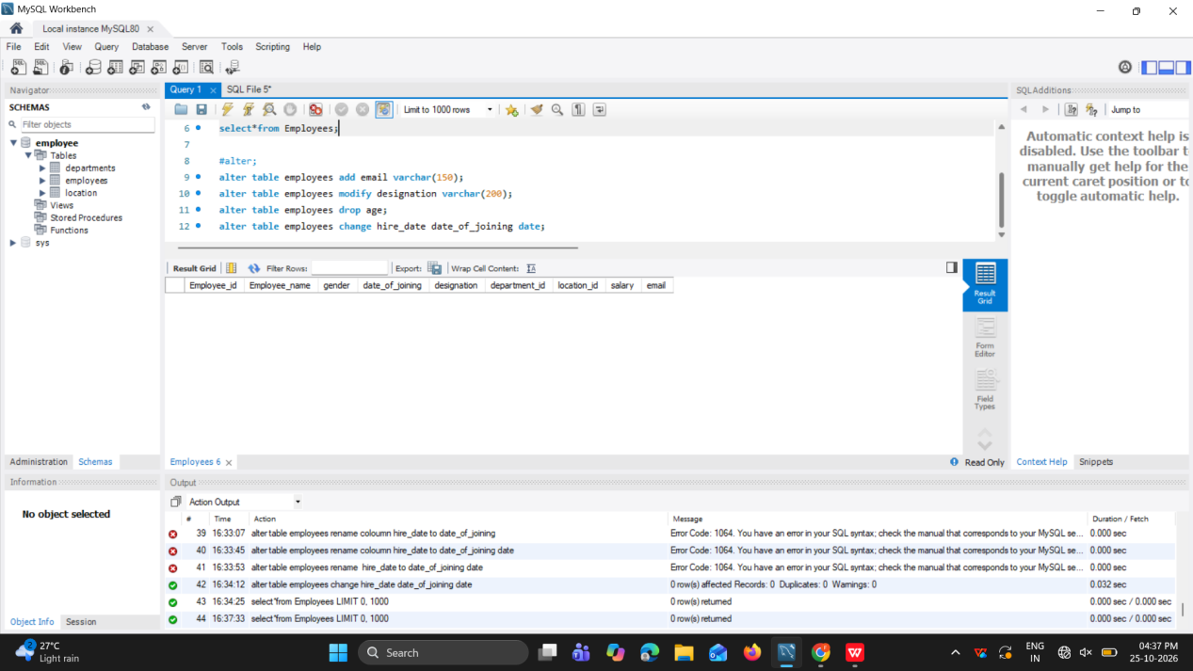

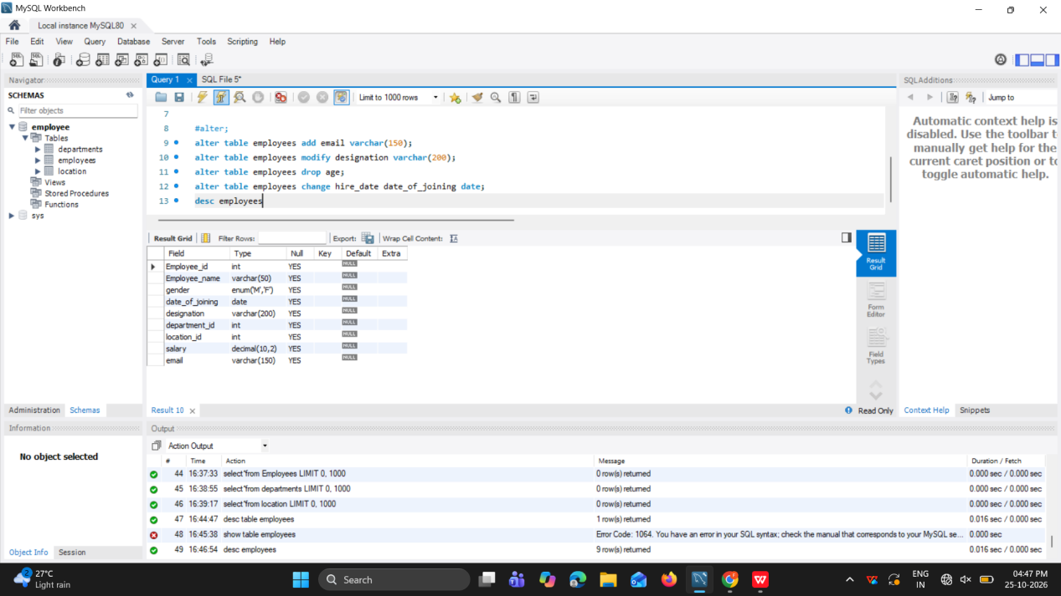

- Table Renaming (RENAME):
Rename the "Departments" table to "Departments_Info"
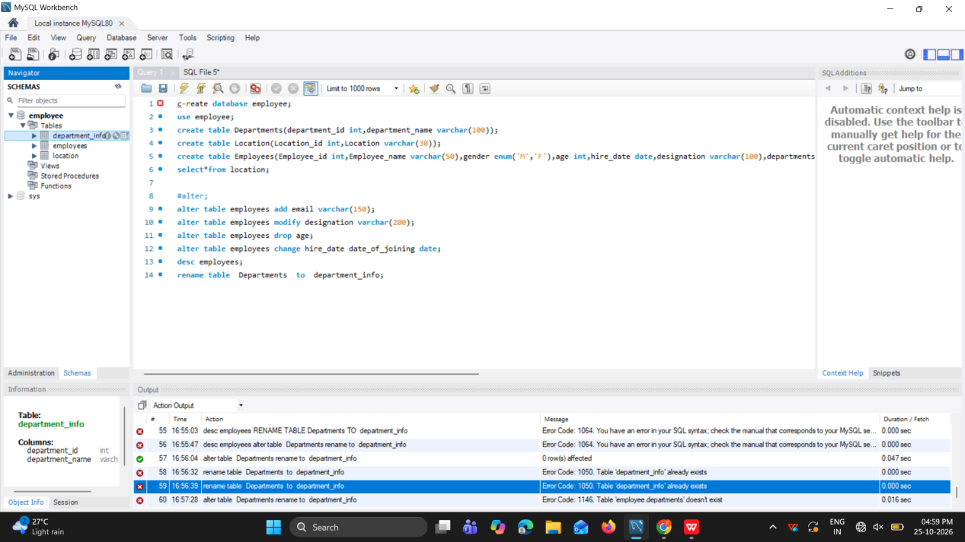

⦿ Rename the "Location" table to "Locations"

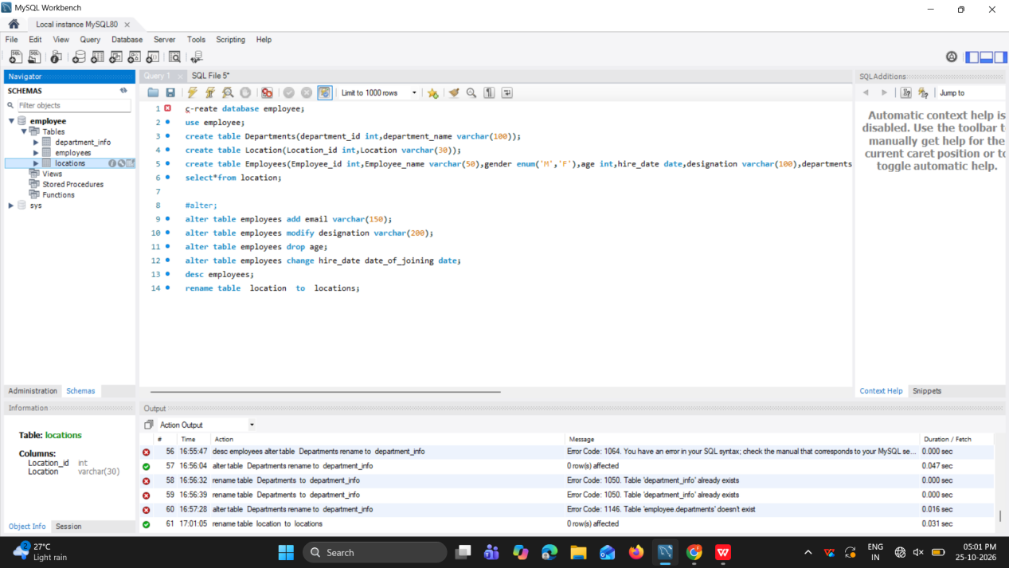

- Table Truncation (TRUNCATE):
Write an SQL statement to truncate the
Employees table.

truncate table employees;

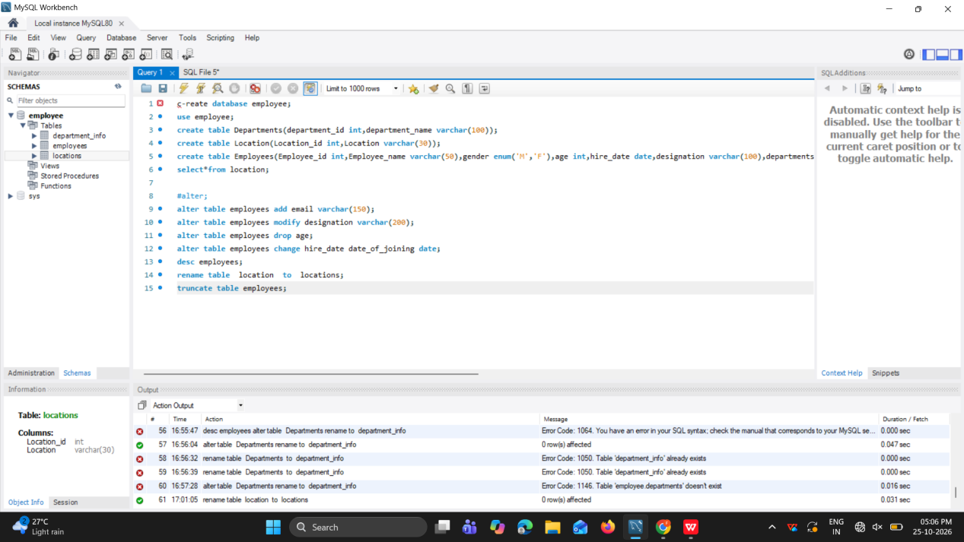

5.Database & Table Dropping (DROP): Write the SQL statements to drop the
Employees table and then the “employee” database.

drop table employees;
drop database employee;

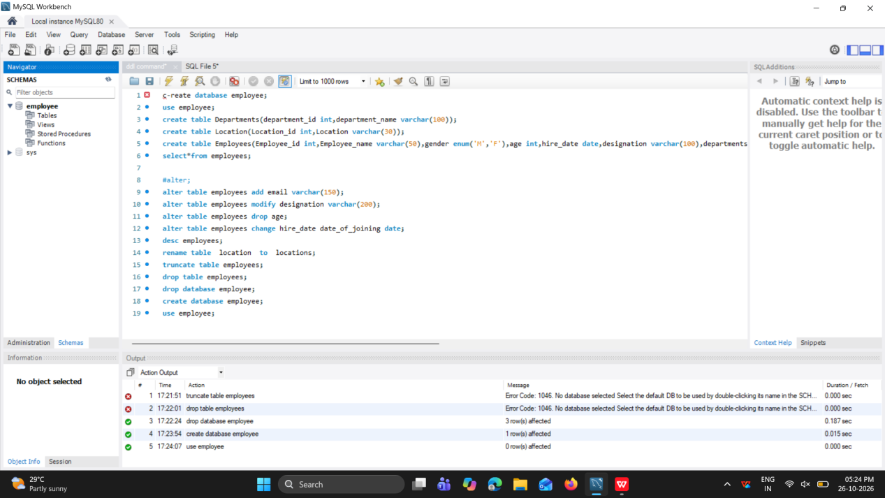
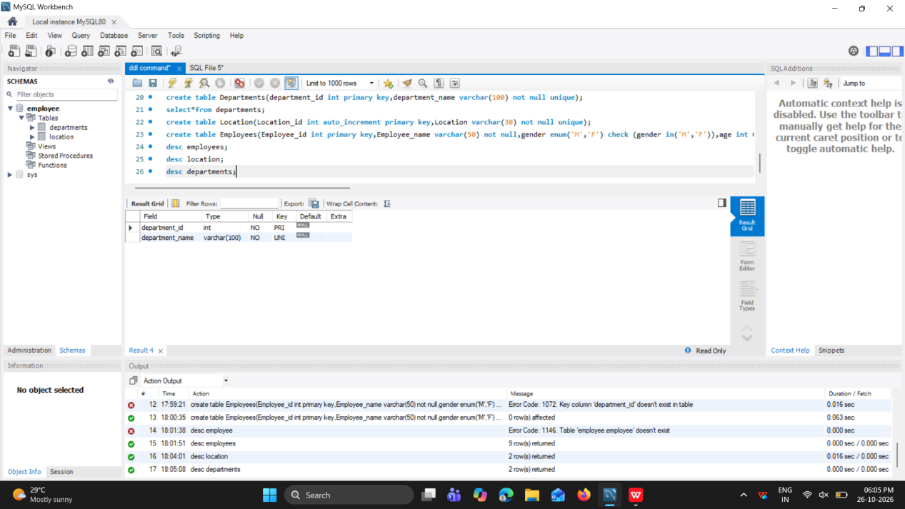

Constraints :
Departments Table:
⦿ Ensure that the "department_id" uniquely identifies each department.
⦿ Set up constraints on the "department_name" to avoid duplicate and null
entries.

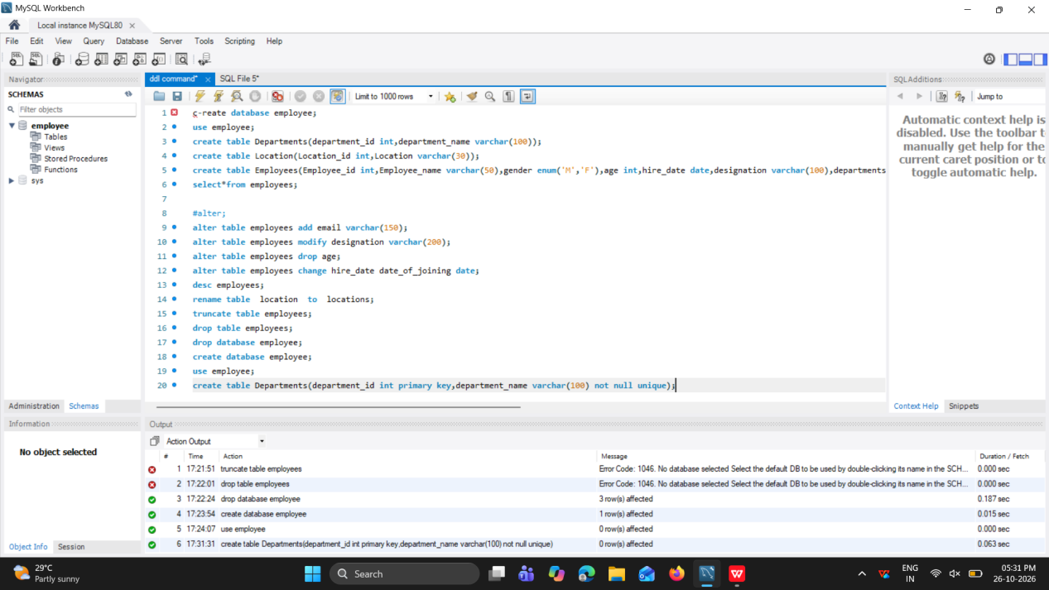

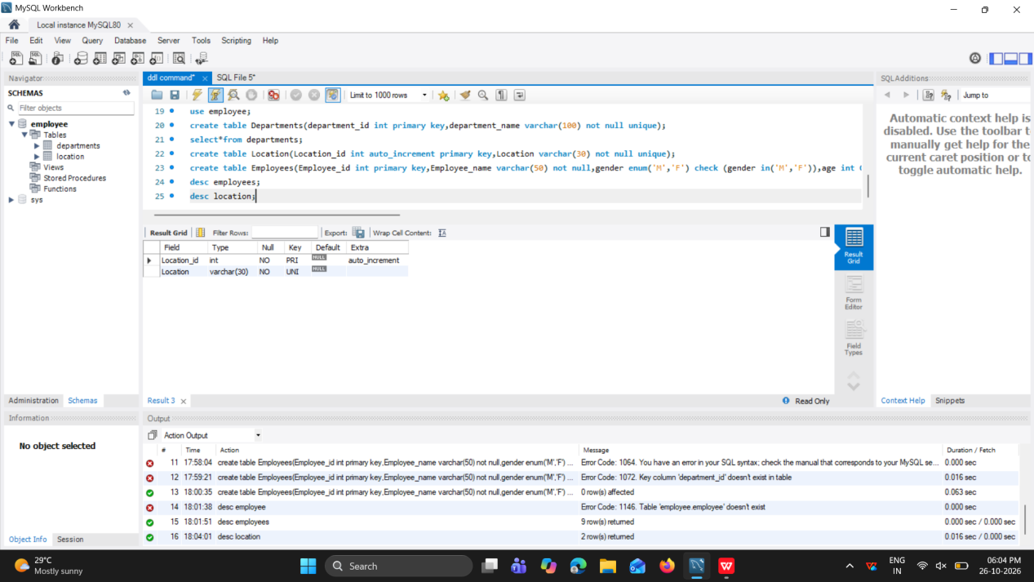

3. Location Table:
⦿ Establish a mechanism to automatically generate unique identifiers for
each location, ensuring that they are incremented sequentially.
⦿ Implement constraints to prevent the insertion of null and duplicate
Locations

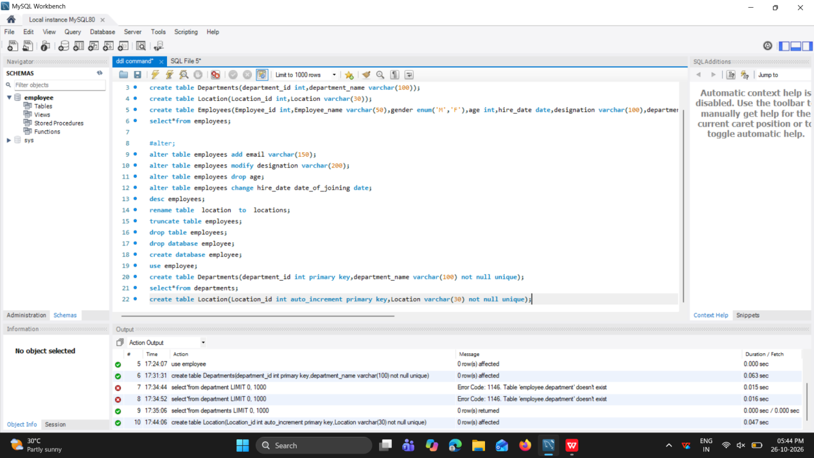

Employees Table:
⦿ Guarantee that each employee has a distinct identifier.
⦿ Create a restriction to ensure that the employee's name is always
provided.
⦿ Limit the acceptable values for the "gender" field to only 'M' or 'F'.
⦿ Enforce a condition to ensure that the employee's age is 18 or above.
⦿ Automatically assign the current date to the "hire_date" field if not
specified.
⦿ Establish links between the "department_id" and "location_id" fields in
the "employees" table and their respective tables.

